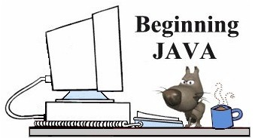
Using BreezyGUI
Working with GUI's
GUI stands for "Graphical User Interface"
A GUI, (often pronounced "GOO-ee"), is a means of interacting with a computer which utilizes the computer's graphical capabilities (such as input boxes, buttons, windows, etc) in addition to text to engage the user. While GUI's make it easier for a user to learn to use a program, they are often more difficult for a computer programmer to code. This is especially true for beginning Java programmers.
The Java language has a complex Abstract Windowing Toolkit (AWT) for developing GUIs which can be very challenging for new programmers. BreezyGUI, on the other hand, is an easy to use interface toolkit that allows beginning programmer to work with the AWT without dealing with the AWT's challenging complexities. New programmers get to experience the "fun" of working with GUI's and to experience the flavor of commercial programs.

